

**JAVA CODE:**

import java.util.Scanner;

class Perfect {

static boolean checkPerfect(int num) {

int sum = 0;

for (int i = 1; i <= num / 2; i++) {

if (num % i == 0) {

sum += i;

}

}

return sum == num;

}

public static void main(String[] args) {

Scanner scanner = new Scanner(System.in);

System.out.print("Enter the starting range: ");

int start = scanner.nextInt();

System.out.print("Enter the ending range: ");

int end = scanner.nextInt();

scanner.close();

int count = 0;

System.out.println("Perfect numbers in the given range are:\n");

for (int i = start; i <= end; i++) {

if (checkPerfect(i)) {

System.out.println(i + " is a perfect number");

count++;

}

}

System.out.println("There are " + count + " perfect numbers in the given range.");

}

}

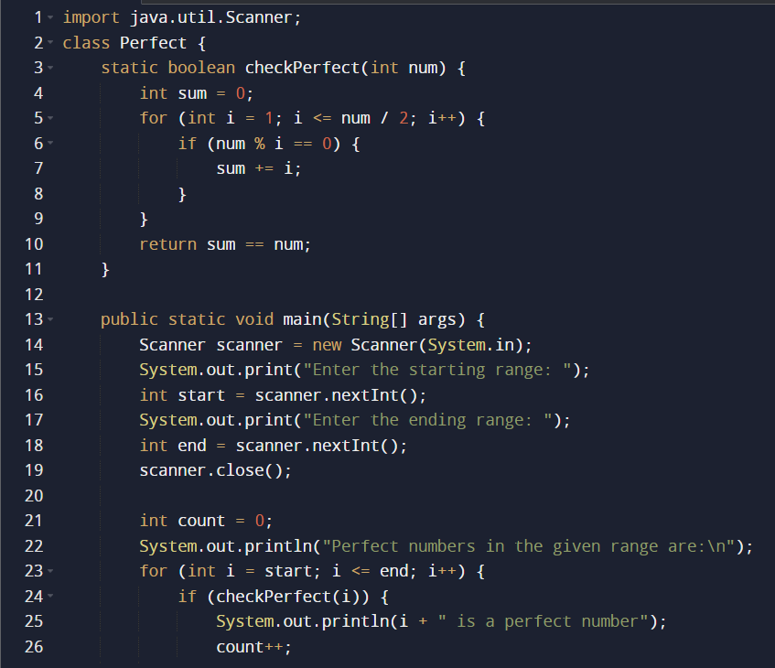

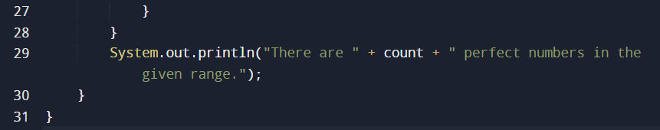

**Output:**

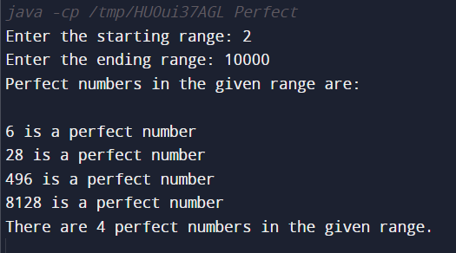

**JAVA CODE WITH VARIATION A:** main() and checkPerfect() should be in separate classes and checkPerfect() should be static.

import java.util.Scanner;

class PerfectChecker {

static boolean checkPerfect(int num) {

int sum = 0;

for (int i = 1; i <= num / 2; i++) {

if (num % i == 0) {

sum += i;

}

}

return sum == num;

}

}

class Perfect {

public static void main(String[] args) {

Scanner scanner = new Scanner(System.in);

System.out.print("Enter the starting range: ");

int start = scanner.nextInt();

System.out.print("Enter the ending range: ");

int end = scanner.nextInt();

scanner.close();

int count = 0;

System.out.println("Perfect numbers in the given range:\n");

for (int i = start; i <= end; i++) {

if (PerfectChecker.checkPerfect(i)) {

System.out.println(i + " is a perfect number.");

count++;

}

}

System.out.println("There are " + count + " perfect numbers in the given range.");

}

}

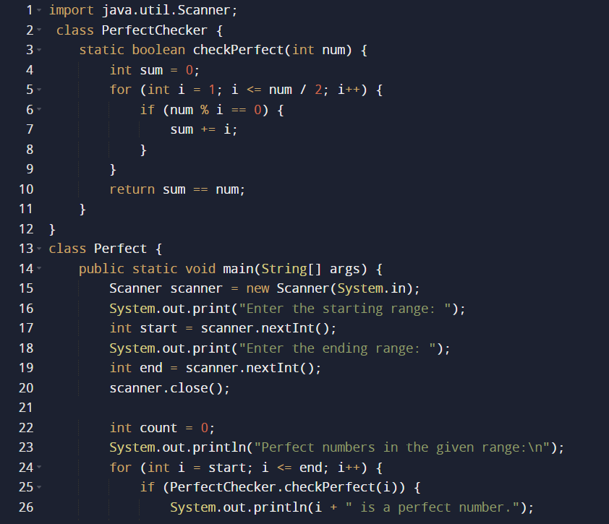

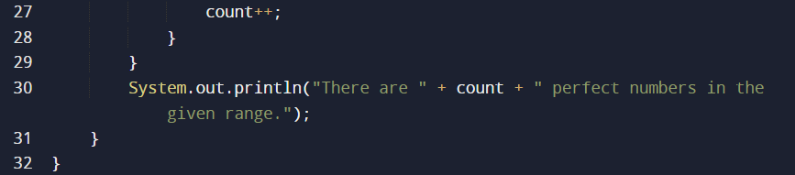

**Output**

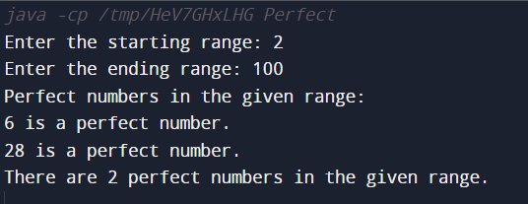

**JAVA CODE WITH VARIATION B:** main() and checkPerfect() should be in separate classes and checkPerfect() should be non-static.

import java.util.Scanner;

class Perfect {

boolean checkPerfect(int num) {

int sum = 0;

for (int i = 1; i <= num / 2; i++) {

if (num % i == 0) {

sum += i;

}

}

return sum == num;

}

}

class PerfectChecker {

public static void main(String[] args) {

Scanner scanner = new Scanner(System.in);

System.out.print("Enter the starting range: ");

int start = scanner.nextInt();

System.out.print("Enter the ending range: ");

int end = scanner.nextInt();

scanner.close();

Perfect perfect = new Perfect();

int count = 0;

System.out.println("Perfect numbers in the given range:");

for (int i = start; i <= end; i++) {

if (perfect.checkPerfect(i)) {

System.out.println(i + " is a perfect number.");

count++;

}

}

System.out.println("There are " + count + " perfect numbers in the given range.");

}

}

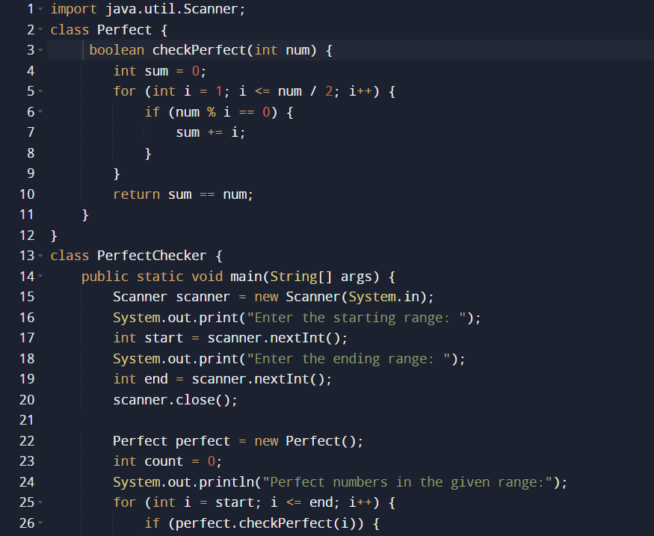

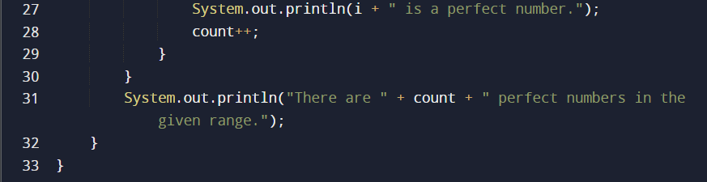

**Output**

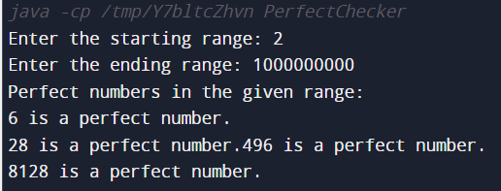

**C CODE:**

#include <stdio.h>

// Function to check if a number is a perfect number

int check_perfect(int num) {

int sum_of_divisors = 1; // Initialize with 1 as all numbers are divisible by 1

for (int i = 2; i * i <= num; i++) {

if (num % i == 0) {

sum_of_divisors += i; // Add divisor

if (i * i != num) {

sum_of_divisors += num / i; // Add the other divisor

}

}

}

return sum_of_divisors == num; // Check if the sum of divisors is equal to the number itself

}

int main()

{

int start_range, end_range;

printf("Enter the starting number of the range: ");

scanf("%d", &start_range);

printf("Enter the ending number of the range: ");

scanf("%d", &end_range);

int count_perfect = 0;

int perfect_numbers[100]; // Assuming the range will have at most 100 perfect numbers

printf("Perfect numbers in the range [%d, %d]: ", start_range, end_range);

for (int num = start_range; num <= end_range; num++) {

if (check_perfect(num)) {

perfect_numbers[count_perfect] = num;

count_perfect++;

}

}

for (int i = 0; i < count_perfect; i++) {

printf("%d ", perfect_numbers[i]);

}

printf("\nTotal number of perfect numbers: %d\n", count_perfect);

return 0;

}

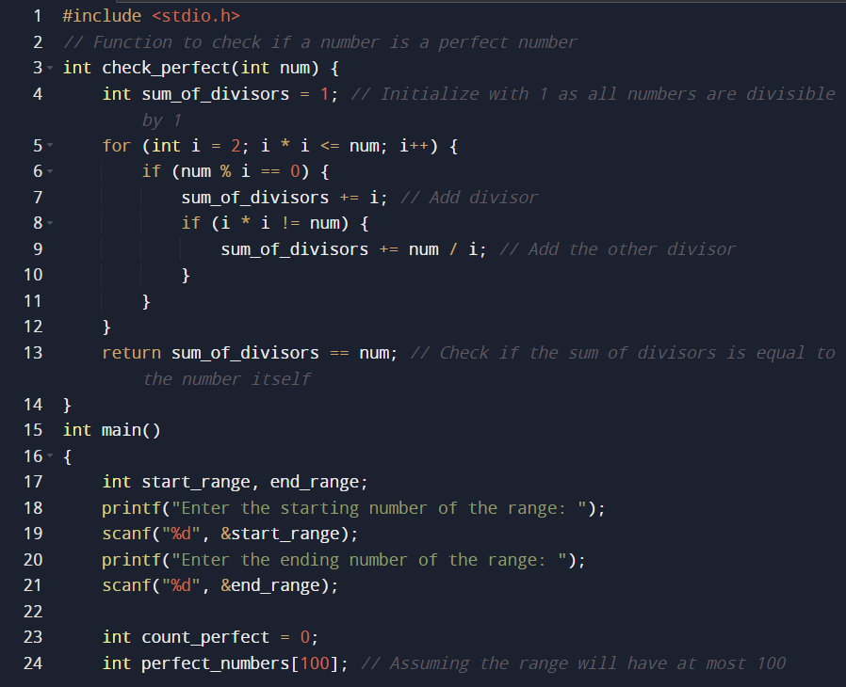

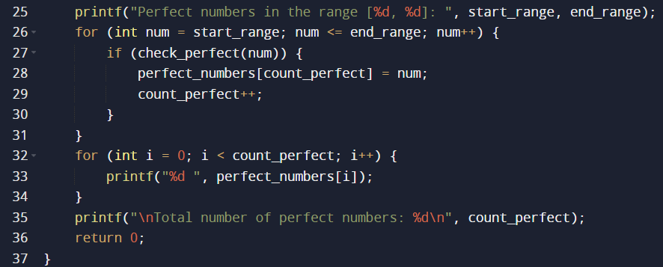

**Output**

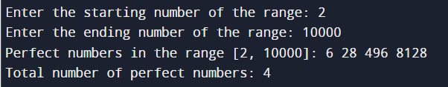

**PYTHON CODE:**

class Perfect:

def check_perfect(self, num):

# Function to check if a number is a perfect number

divisors = [1] # Initialize with 1 as all numbers are divisible by 1

for i in range(2, int(num ** 0.5) + 1):

if num % i == 0:

divisors.extend([i, num // i]) # Add both divisors to the list

return sum(set(divisors)) == num # Check if the sum of divisors is equal to the number itself

# Input the range from the user

start_range = int(input("Enter the starting number of the range: "))

end_range = int(input("Enter the ending number of the range: "))

count_perfect = 0

perfect_numbers = []

# Create an instance of the Perfect class

perfect_checker = Perfect()

for num in range(start_range, end_range + 1):

if perfect_checker.check_perfect(num):

count_perfect += 1

perfect_numbers.append(num)

print(f"Perfect numbers in the range [{start_range}, {end_range}]: {perfect_numbers}")

print(f"Total number of perfect numbers: {count_perfect}")

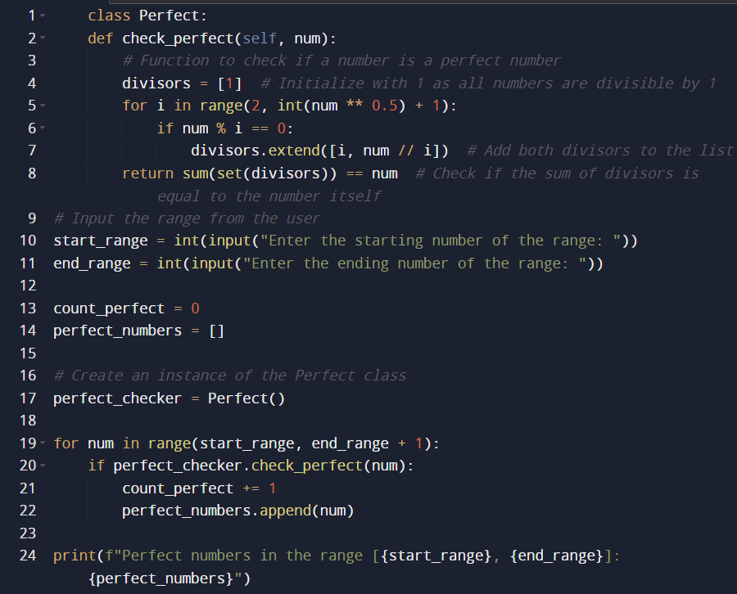

**Output:**

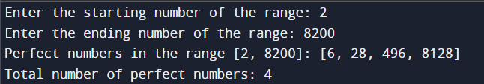

**Post Lab Descriptive Questions:**

Q.1 Write a program to find the area and circumference of a circle using two classes.

import java.util.Scanner;

public class Circle {

public static void main(String[] args) { Scanner sc = new Scanner(System.in); System.out.print("Enter the radius: "); double radius = sc.nextDouble();

System.out.println("Area: " + Area.area(radius)); System.out.println("Circumference: " +

Circumference.circumference(radius)); sc.close();

}

}

class Area {

public static double area(double radius) {

return Math.round(Math.PI * radius * radius * 10000.0) / 10000.0;

}

}

class Circumference {

public static double circumference(double radius) {

return Math.round(2 * Math.PI * radius * 10000.0) / 10000.0;

}

}

Q2. Write the output of following program

public class BreakExample2 {

public static void main(String[] args) {

// outer loop

for (int i = 1; i <= 3; i++) {

// inner loop

for (int j = 1; j <= 3; j++) { if (i == 2 && j == 2) {

// using break statement inside the inner loop break;

}

System.out.println(i + " " + j);

}

}

}

}

**Output:**

**1 1**

**1 2**

**1 3**

**2 1**

**3 1**

**3 2**

**3 3**

Q3. Why is Java known as a platform independent language?

**Ans**. The java language is known as a platform independent language because any code which is written in java is converted to an intermediate form known as byte code which is independent of the machine on which the program is run or compiled on. It is the same for all platforms. Whenever the program is to be executed, the byte code is converted to machine code by the Java virtual machine (JVM) which converts the java compiled byte code into machine code which is different for each machine.

Q4. Write a recursive static method for calculation of gcd of a number.

public static void gcd(int a, int b) { if (b == 0) {

System.out.println("GCD is " + a);

} else {

gcd(b, a % b);

}

}